EASTERN BOX TURTLE POPULATION MONITORING PROTOCOL

Northeast Eastern Box Turtle Working Group
Supported by the Northeast Regional Conservation Needs (RCN) Program
www.northeastturtles.org

DRAFT: 11/23/19

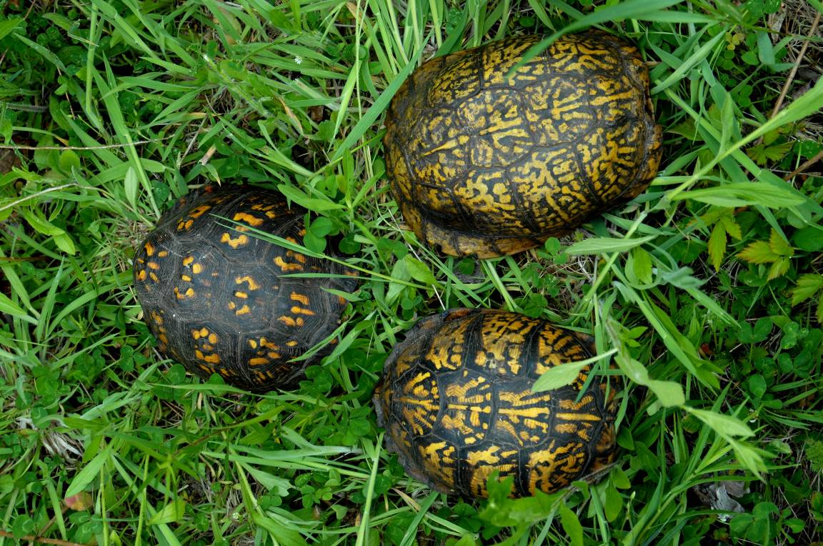

This document outlines the 2019 Eastern Box Turtle (Terrapene carolina carolina) Population Monitoring Protocol developed by the Northeast Eastern Box Turtle Working Group. This standardized sampling protocol is intended to provide a framework for assessing Eastern Box Turtle populations throughout the northeastern United States. The basic elements of the protocol include Rapid Assessments (RA) and Demographic Assessments (DA). RAs are intended to allow for the efficient assessments of relative abundance at a given site, while DAs, which require more intensive sampling using the same protocol, provide a means for estimating population size and other demographic parameters. Three sampling options are described: (Option 1) circular-plot based sampling (strongly encouraged), (Option 2) feature polygon-based sampling, and (Option 3) random plot sampling (intended for assessing managed areas). Early sampling will primarily be focused on a visual survey approach, but we also recommend the evaluation and potential future inclusion of two additional approaches (i.e., trap-assisted and dog-assisted surveys). This standardized population monitoring protocol is designed to be flexible, and to allow use in a variety of habitat and project types throughout the northeastern United States and elsewhere throughout the species range.

Goal:
Provide a flexible and efficient framework for detecting and monitoring Eastern Box Turtle populations that will facilitate the assessment of distributional trends, patterns of occupancy and abundance, long-term population trends, and effects of habitat management throughout the northeastern United States.

Objectives:
- Assess Eastern Box Turtle occupancy and relative abundance throughout the northeastern United States.
- Provide a framework for tracking trends in occupancy over time.
- Quantify population densities for a subset of sampled populations.
- Provide a framework for tracking trends in population density over time.
- Assist in the evaluation of the effects of habitat management actions on Eastern Box Turtle populations.
- Provide a flexible, yet standardized monitoring framework that is compatible with monitoring efforts throughout the range, including citizen science efforts.

GUIDELINES

Site Selection

A survey site may be any area containing habitat that could potentially support Eastern Box Turtles (e.g., early successional, forest, or ecotone conditions). Ideally, survey sites should be located >1,200 m apart (approx. twice the average annual movement distance in Massachusetts [Willey 2010]). Alternatively, sites can be chosen <1,200 m apart, but should be separated by a clear barrier to movement (e.g., lake or 4 lane highway). For sites that are unfamiliar to surveyors, performing a reconnaissance site visit is advisable to assess site access and current ground conditions of survey areas. In an attempt to ecologically and geographically stratify sampling efforts across the region, provisionary sampling targets for physiographic areas and states are provided at the end of this document (Fig. 1, 2; Table 1). It is also recommended that, where possible, surveyors select survey sites along a gradient of rural-urban conditions, habitat patch sizes, and habitat types.

Below we describe methods for defining your specific survey area within survey sites for three different survey methods. Option 1 (circular plot survey) is the recommended method at this time. Option 2 (feature survey) is provided for surveyors that do not have access to specialized mapping program (beyond Google Earth) and/or GPS units. Option 3 (random plot placement) should primarily be used in managed areas where extrapolation of survey returns is a priority.

Option 1 (strongly preferred): Circular plot survey
Within your site, place four 28-m radius (1/4 ha) circular plots centered within suitable habitat or potentially suitable Eastern Box Turtle habitat (Fig 3). For example, suitable habitat may be a field-forest ecotone, section of a power line corridor, old gravel pit, or a patch of forest. The Northeast Eastern Box Turtle Working Group (NEEBTWG) recommends that surveyors target early-successional habitat adjacent to mature forest, but surveyors may also consider other areas frequently used by Eastern Box Turtles during the spring months in your region (e.g., forested habitats). The four paired circular sampling plots should be non-overlapping and no more than 350 m from each other (approximately ½ the average distance between overwintering location and early successional habitat in Massachusetts [Willey 2010]).

Option 2: Feature polygon survey
Within a selected site, delineate a polygon encompassing a feature polygon that will be surveyed (Fig 4). A “feature” is defined as any component/aspect of the landscape consisting of suitable or potentially suitable Eastern Box Turtle habitat. For example, suitable habitat may be a field-forest ecotone, section of a power line corridor, old gravel pit, or a patch of forest. The NEEBTWG recommends that surveyors target early-successional habitat adjacent to mature forest, but surveyors may also consider other areas frequently used by Eastern Box Turtles during the spring months in your region (e.g., forested habitats). Delineated feature polygons should be 2–4 ha in size and take on any shape. A feature polygon size of 3 ha is recommended for any sites with ≥3 ha of suitable habitat present. Multiple features may be designated at a single large site (e.g., state park with multiple patches of field/forest ecotone habitat patches) if they are separated by >1,200 m OR a barrier to movement (i.e., 4-lane highway, lake, larger river).

Option 3: Random plot surveys in managed habitat
This option is intended primarily for assessing management areas (pre- or post-management). For each site, delineate a polygon encompassing the habitat management treatment area (e.g., prescribed burn or timber harvest site) within Eastern Box Turtle habitat. Use GIS or another mapping program to generate random points throughout the delineated treatment area. These will be the center of your sampling plots, and should be no closer than 56 m from each other to ensure non-overlapping plots. Generate 1 random point per ha of habitat, except treatment areas >10 ha in size, generate a minimum of 10 random points. Using GIS create a ¼ ha (28 m radius) circular plot (buffer) around each random point. These buffers will serve as sampling plots.

Visual Encounter Surveys

Rapid Assessment:

Conditions for Surveys
- Sampling period: late April – May (recommended). In more southern locations (mid-Atlantic region and south), mid-April may work for habitat with thin and/or low growing vegetation and June surveys may also be effective. Optimal survey dates may vary by geographic location and yearly variation in spring weather conditions.

- Time of day: 7:00 AM to 3:00 PM

- Weather conditions: Surveys can take place under most weather conditions, but avoid extended (>3 days) cold (< 60 degrees) and hot (> 85 degrees) periods.

Options 1 or 3: Circular Plot Surveys (strongly preferred)
- Sampling area: Sampling plots should be searched as evenly and thoroughly as possible. Surveyors may find it useful to create and upload plot boundary points or plot center points into a GPS unit, or use Google Earth on their cell phone (if cell reception is available) to help guide them during the survey. If the center points in a GPS, surveyors can use the “go to” feature to stay within 28 m of the center point.

- Number of surveys: Each set of plots should be surveyed 3 times within a single season.

- Survey effort: Each ¼ ha sampling plot should be searched for a total of 0.25 person hrs (total of 1 hour of active search time over 1 ha of a selected feature during each visit). This excludes time spent processing turtles. If 1 person is surveying the plot, they would actively search for 15 minutes, if two surveyors are surveying the plot, they would search for 7.5 minutes each. No more than 2 surveyors should be used at a given plot. It is recommended that no more than 2 surveyors sample a site during each survey. However, when >2 surveyors are used they should survey different plots so that no more than 2 surveyors search a single plot. All sampling plots within the same site should be surveyed during the same day and at least 48 hours should separate any two sampling events at a given site.

- Survey effort for thickly vegetated sites (see Fig 5 and 6): The time to survey each plot should be doubled to 0.50 person hours per plot in instances where the vegetation is very thick and it is difficult to see the ground.

- Data: It is highly recommended to record tracks during surveys. GPS unit or app can be used to save an independent set of tracks for each survey. Please see the data forms for track naming convention. Please see the data forms for track file naming convention. The start time, end time, weather conditions, and habitat features will be noted. Survey field forms can be found in Attachment B and at northeastturtles.org.

Option 2: Feature Survey
- Sampling area: The entire feature should be surveyed as evenly and thoroughly as possible. Surveyors may find it useful to create and upload feature boundary points into a GPS unit, or use Google Earth on their cell phone to help guide them during the survey.

- Number of surveys: Each feature should be surveyed 3 times within a single season and least 48 hours should separate any two sampling events at a given feature.

- Survey effort: During each survey, surveyors should spend 1.0 person hours per hectare searching for turtles. This excludes time spent processing turtles. It is recommended that no more than 2 surveyors be used during a single survey, however if additional surveyors are used the survey time should be modified accordingly (see Table 2).

- Survey effort for thickly vegetated sites (see Fig 5 and 6): The time to survey each plot should be doubled to 2 person hours per hectare.

- Data: It is highly recommended to record tracks during surveys. GPS unit or app can be used to save an independent set of tracks for each survey. Please see the data forms for track naming convention. Please see the data forms for track file naming convention. Survey start time, end time, weather conditions, turtles observed, and habitat features will be noted. Survey field forms will be provided.

Demographic Assessment:

Visual Surveys (preferred)
For demographic assessments, features will be delineated as described above, and the Rapid Assessment methodology will be followed. A minimum of four to six additional survey events will also be required for a total of ≥7-9 independent surveys (dependant on the number of recapture events) at demographic sites within a two-year time frame. Survey Option 3 should not be used for Demographic Assessments.

Data Analysis:

Rapid assessment visual surveys are designed to evaluate occupancy and relative abundance at the broad scale and will be used to track those parameters at the regional level over time using N-mixture, Royle-Nichols, or other occupancy models (Royle and Nichols 2003; Royle 2004). Rapid assessments require 3 surveys/site. Demographic assessments will utilize mark-recapture techniques to fit log-linear, spatially explicit capture-recapture (Efford and Fewster 2013), or open population models (e.g., Pledger et al. 2003) to estimate population size at specific sites and require a minimum of 7-9 surveys at a given site.

Alternative Methodologies under Evaluation

Trap-Based Surveys:

Where time and resources allow it would be valuable to evaluate trapping with use of drift fences and passive unbaited box traps with adjustable wings (Fig 7) as a potential alternative method for a demographic assessment. We recommend use of 2-4 drift fences of 56 m in length (equivalent to the diameter of a ¼ ha circular plot) (Fig 8). Silt fencing material would work well for the drift fence. Trap density should be 12 traps/plot with traps placed on either end of the drift fencing and on both sides of the fencing (Fig 9) as well as approximately every 10 m along the drift fence on both sides. Traps should be deployed for X trap nights and checked daily.

Dog-Assisted Surveys:

Dog-assisted surveys should be evaluated as an additional optional survey method for both RA and DA population assessments. The protocol would follow the same survey conditions and sampling methods as the visual encounter surveys. We recommend a comparison study between the visual encounter surveys and dog-assisted surveys. This would be done by alternating human versus dog-assisted survey at each site. Evaluation of the effects of weather conditions on detection will be important. Surveyors should note the weather conditions for the week prior to the surveys, as well as during the survey, to determine if detection varies under different weather conditions for dog-assisted surveys. In particular, rain events and humidity should be tracked. Survey field forms will be provided.

Other Survey Requirements

All participants must have permits from their state wildlife agency, IACUC protocol if necessary (for University associated research), and follow the NEPARC disinfection protocol (http://www.northeastparc.org/products/pdfs/NEPARC_Pub_2014-02_Disinfection_Protocol.pdf).

Literature Cited

Efford M.G. and R.M. Fewster. 2013. Extimating population size by spatially explicit capture-recapture. Oikos 122(6):918-928.
Pledger, S., K.H. Pollock and J.L. Norris. Open capture-recaputre models with heterogeneity: I. Cormack-Jolly-Seber Model. Biometircs 59(4):786-794.
Royle, J.A. 2004. N-mixture models for estimating population size from spatially replicated counts. Biometrics 60:108-115.
Royle J.A., and J.D. Nichols. 2003. Estimating abundance from repeated presence-absence data or point counts. Ecology 84(3):777-790.
Wiley L.L. 2010. Spatial ecology of eastern box turtles (Terrapene c. carolina) in central Massachusetts. Dissertation, University of Massachusetts, Amherst, USA.

Figures
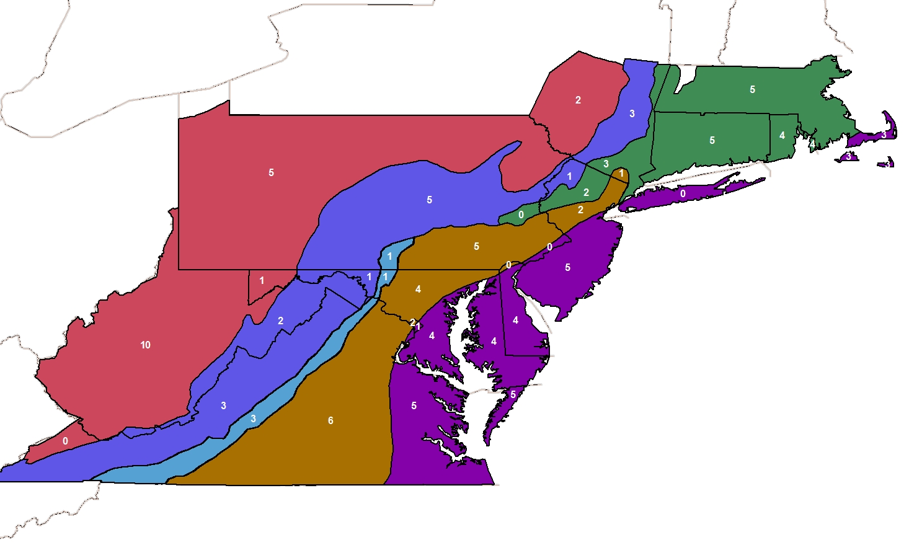Figure 1. Provisionary target number of Rapid Assessment survey sites by physiographic province and state.

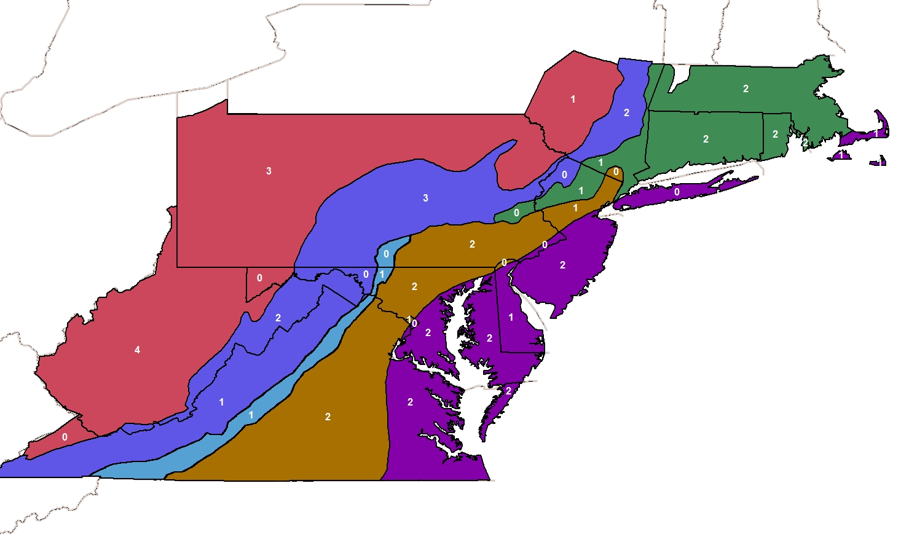
Figure 2. Provisionary target number of Demographic Assessment survey sites by physiographic province and state.
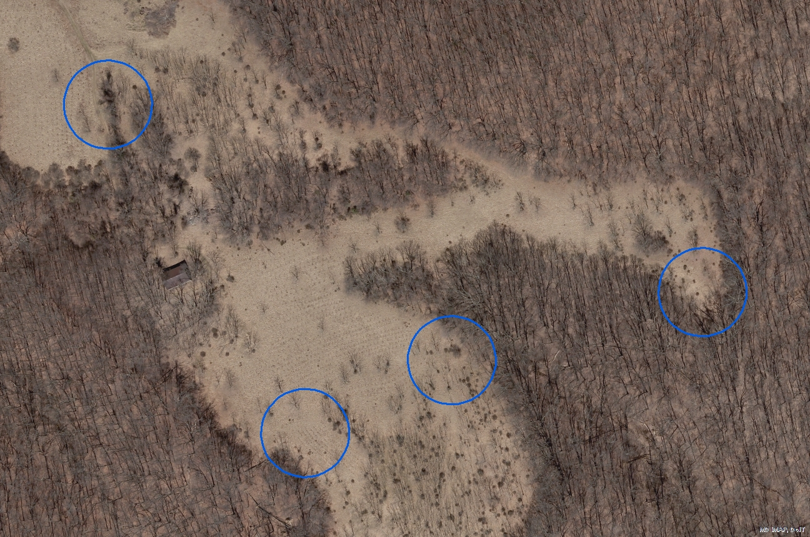
340 m
Figure 3. Four ¼ ha sampling plots (blue) within suitable Eastern Box Turtle Habitat. Each plot has a 28 m radius and the two plots furthest from each other are within 350 m of each other.

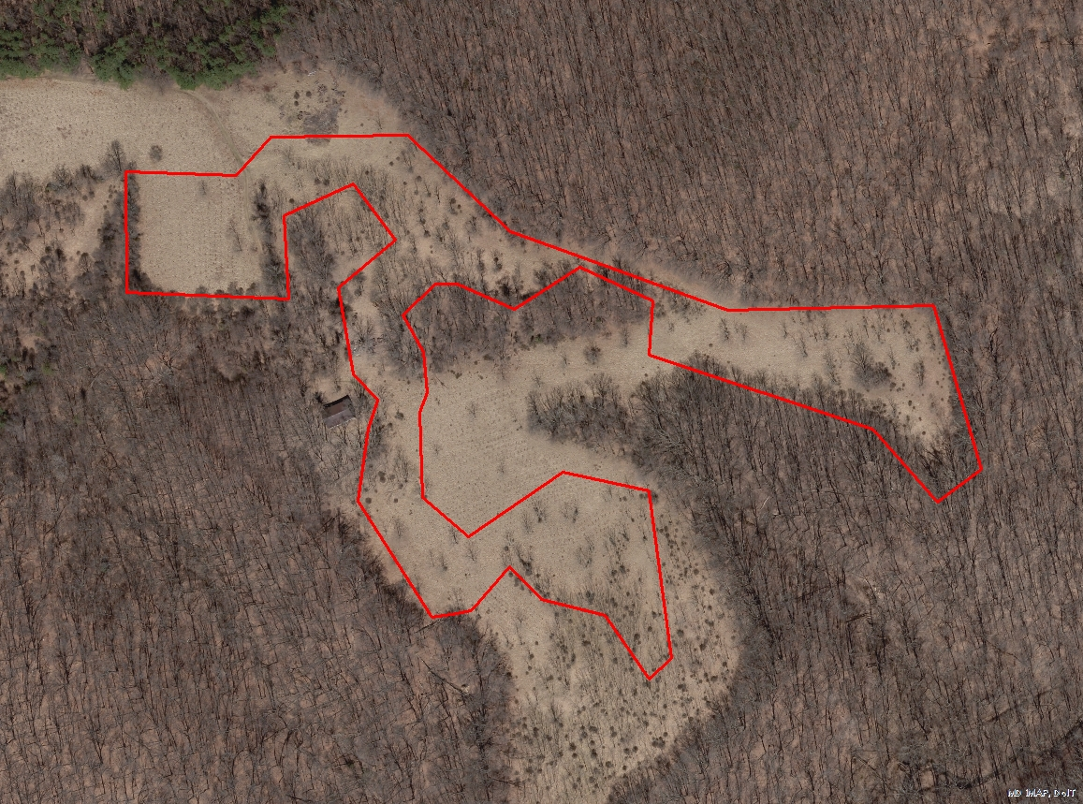
Figure 4. A feature polygon (red) within a site.
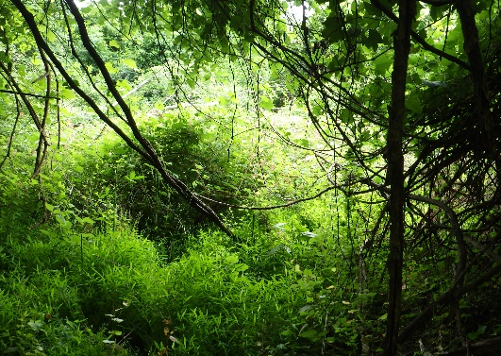
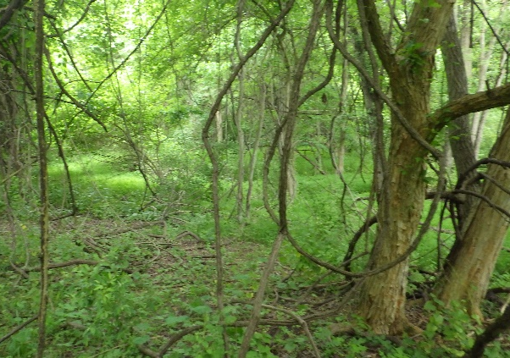

Figure 5. Image of a thinly or regularly vegetated habitat on the left and thickly vegetated habitat on the right.

Figure 6. Graphics of thinly vegetated habitats on the left and thickly vegetated habitats on the right.

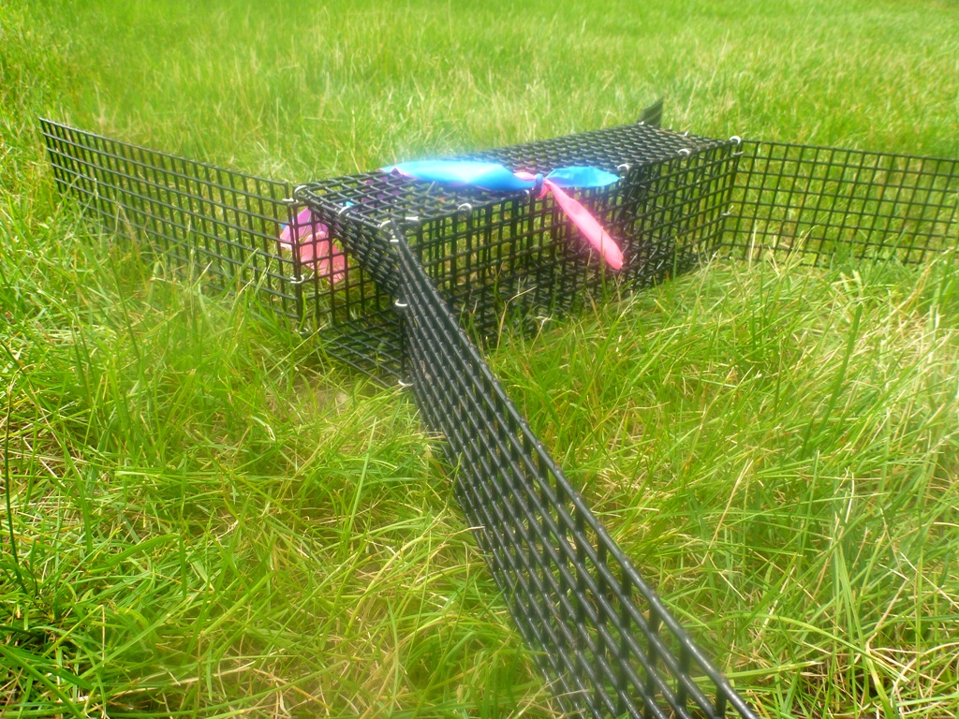
Figure 7. A photo of a passive box trap with adjustable wings.

Figure 8. A diagram of one drift fence and 12 trap set up.

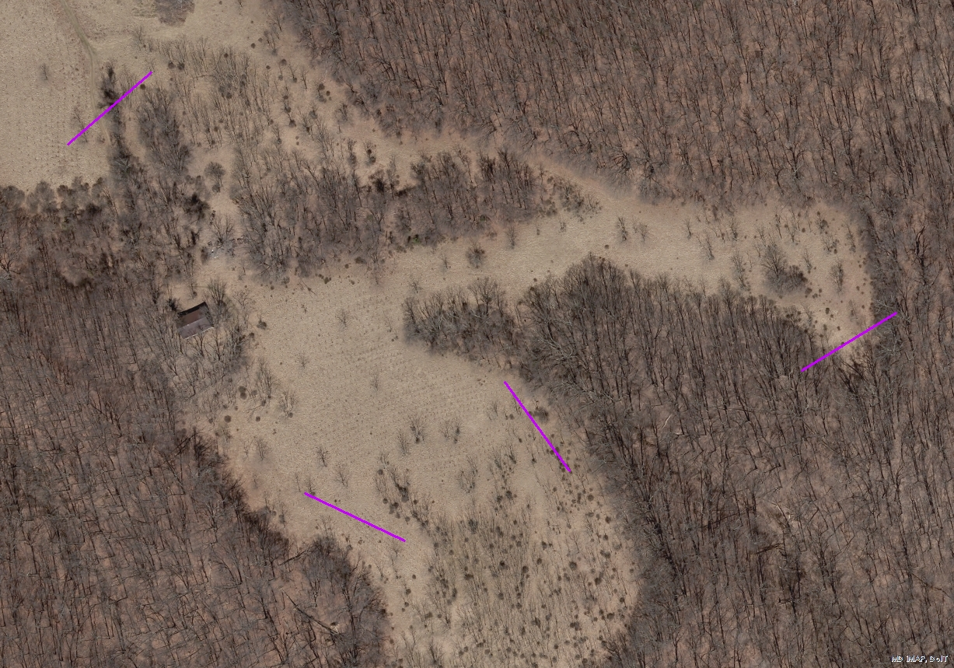
Figure 9. Four 56 m long drift fences set up at a site.

Tables

Table 1. Provisional target numbers of Rapid Assessment (a) and Demographic Assessment (b) sites by physiographic province
and state.

a)
Physiographic Province | CT | DC | DE | MA | MD | NJ | NY | PA | RI | VA | WV | Total
Appalachian Plateaus |  |  |  |  | 1 |  | 2 | 5 |  | 0 | 10 | 18
Blue Ridge |  |  |  |  | 1 |  |  | 1 |  | 3 |  | 5
Coastal Plain |  | 1 | 4 | 3 | 4 | 5 | 0 | 0 |  | 5 |  | 22
New England | 5 |  |  | 5 |  | 2 | 3 | 1 | 4 |  |  | 20
Piedmont |  | 2 | 0 |  | 4 | 2 | 1 | 5 |  | 6 |  | 20
Valley and Ridge |  |  |  |  | 1 | 1 | 3 | 5 |  | 3 | 2 | 15
Total | 5 | 3 | 4 | 8 | 11 | 10 | 9 | 17 | 4 | 17 | 12 | 100

b)
Physiographic Province | CT | DC | DE | MA | MD | NJ | NY | PA | RI | VA | WV | Total
Appalachian Plateaus |  |  |  |  | 0 |  | 1 | 3 |  | 0 | 4 | 8
Blue Ridge |  |  |  |  | 1 |  |  | 0 |  | 1 |  | 2
Coastal Plain |  | 0 | 1 | 1 | 2 | 2 | 0 | 0 |  | 2 |  | 8
New England | 2 |  |  | 2 |  | 1 | 1 | 0 | 2 |  |  | 8
Piedmont |  | 1 | 0 |  | 2 | 1 | 0 | 2 |  | 2 |  | 8
Valley and Ridge |  |  |  |  | 0 | 0 | 2 | 3 |  | 1 | 2 | 8
Total | 2 | 1 | 1 | 3 | 5 | 4 | 4 | 8 | 2 | 6 | 6 | 42

Table 2. Survey time chart to calculate the number of minutes needed to reach a 0.75 person hours/ha of effort given the number of surveyors and area to be surveyed.
Size of Site (ha) | Number of Surveyors
 | 1 | 2 | 3 | 4 | 5
1 | 45 | 23 | 15 | 11* | 9*
1.25 | 56 | 29 | 19 | 14* | 11*
1.5 | 68 | 35 | 23 | 17 | 14*
1.75 | 79 | 40 | 26 | 19 | 16
2 | 90 | 46 | 30 | 22 | 18
2.25 | 101 | 52 | 34 | 25 | 20
2.5 | 113 | 58 | 38 | 28 | 23
2.75 | 124 | 63 | 41 | 30 | 25
3 | 135 | 69 | 45 | 33 | 27
3.25 | 146 | 75 | 49 | 36 | 29
3.5 | 158 | 81 | 53 | 39 | 32
3.75 | 169 | 86 | 56 | 41 | 34
4 | 180 | 92 | 60 | 44 | 36

*Surveys should not be less than 15 min in length.

In Development…

Attachment A: Turtle Processing Protocol

Attachment B: Survey Forms

Attachemnt C: Genetic Assessment Sampling Protocol

Attachment D: Disease Screening Sampling Protocol

Attachment E: PIT Tagging Protocol

